 **Methods 11 Test 1 2017**

**Indices, Exponential Equations, Significant Figures**

**Time Allowed: 55 minutes Total Marks: 52**

**Name: _______________________**

**Resource Free**

**ALL** working must be shown for full marks.

**1.** **[2, 3, 3, 3 = 11 marks]**

Write each in simplest form with positive indices.

a) 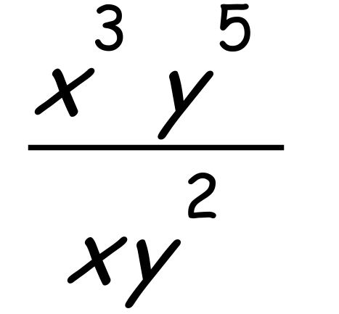 b) 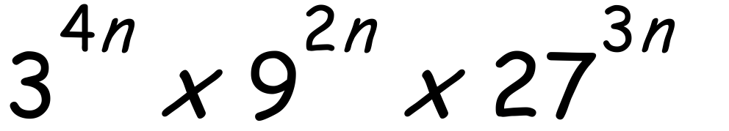

c) $\frac{{\text{3}}^{\text{n+2}}\text{+27}}{\text{5 x }{\text{3}}^{\text{n}}\text{+15}}$ d) 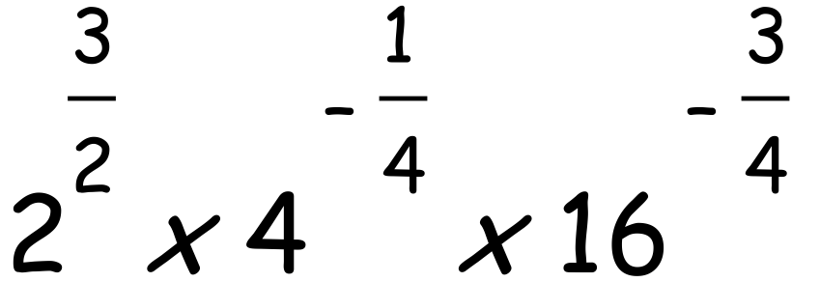

**2.** **[4, 3, 3, 3 = 13 marks]**

Solve the following exponential equations:

a) 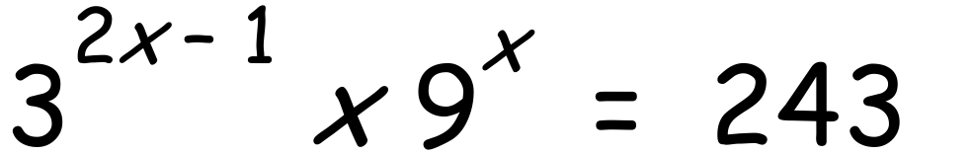 b) 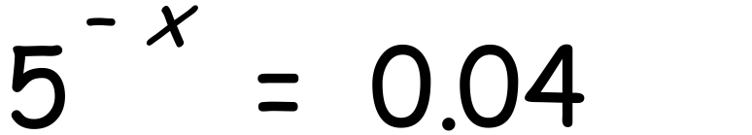

c) 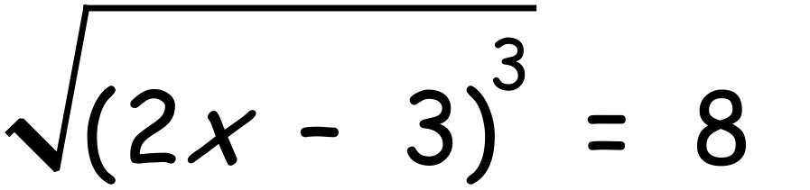 d) 2 $\sqrt[3]{x=12 }$

**3. [2, 3 = 5 marks]**

Estimate the numerical value of the following by rounding to one significant figure:

a) 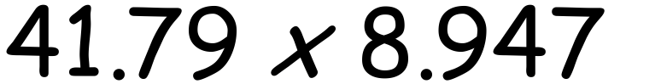 b) 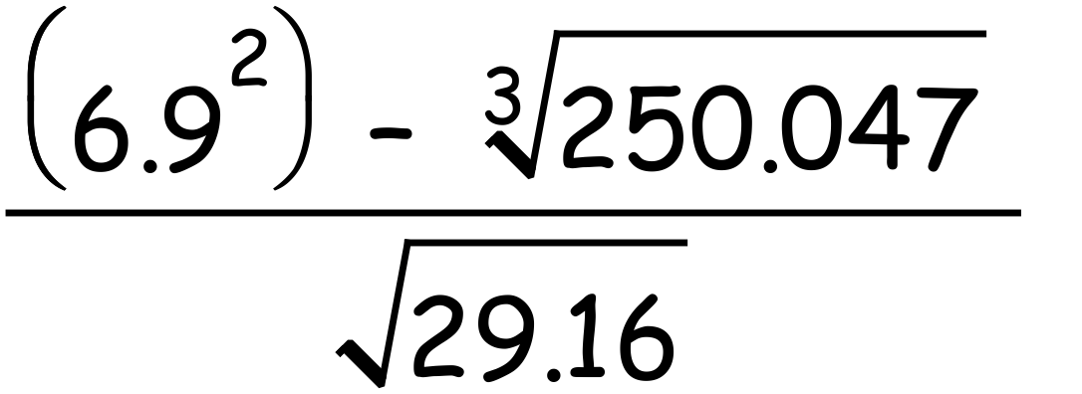

**4. [3, 2, 2, 2 = 9 marks]**

Given that 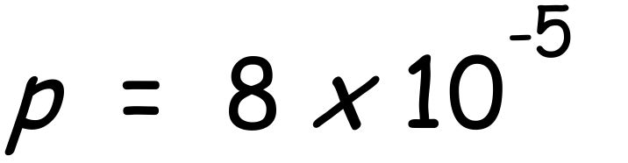 , $\text{q=2 x }{\text{10}}^{\text{4}}$ and $\text{r=3 x }{\text{10}}^{\text{-2}}$, determine each of the following giving exact answers in standard form.

a) pqr b) 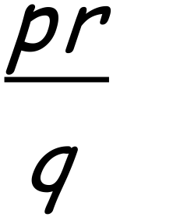

c) p – r d) q + p

**5. [4 marks]**

Write each number in scientific notation correct to 3 significant figures.

a) 251 000

b) 4 827 000

c) 0.00708

d) 3 millionths

**6. [4, 6 = 10 marks]**

Simplify:

a) 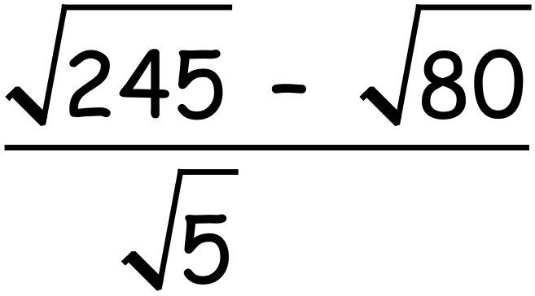 b) $\frac{{\text{3}}^{\text{3x}}\text{- }{\text{9}}^{\text{x+1}}}{\text{1- }{\text{3}}^{\text{2-x}}}$